Microarray Analysis

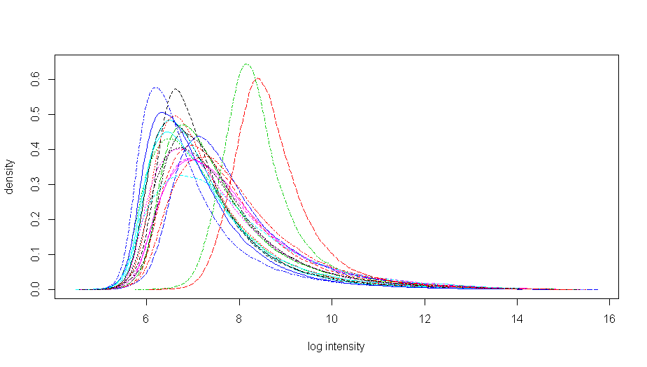
MyBioInfData-Histogram

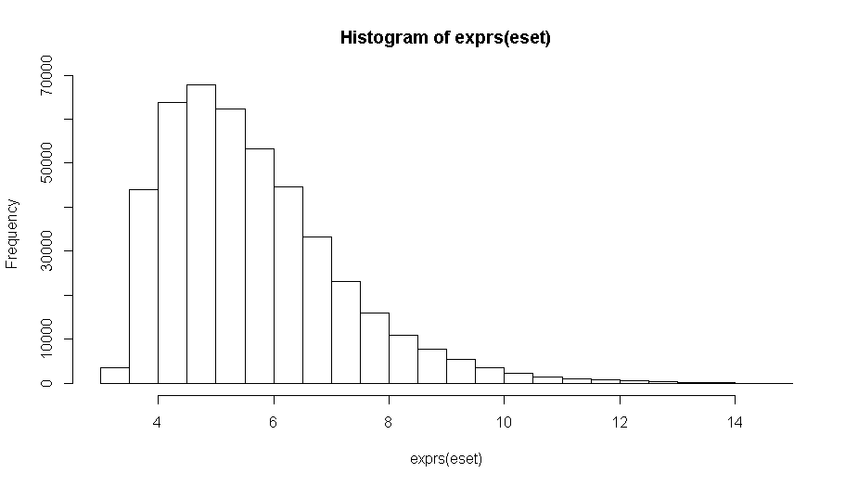
eset Histogram

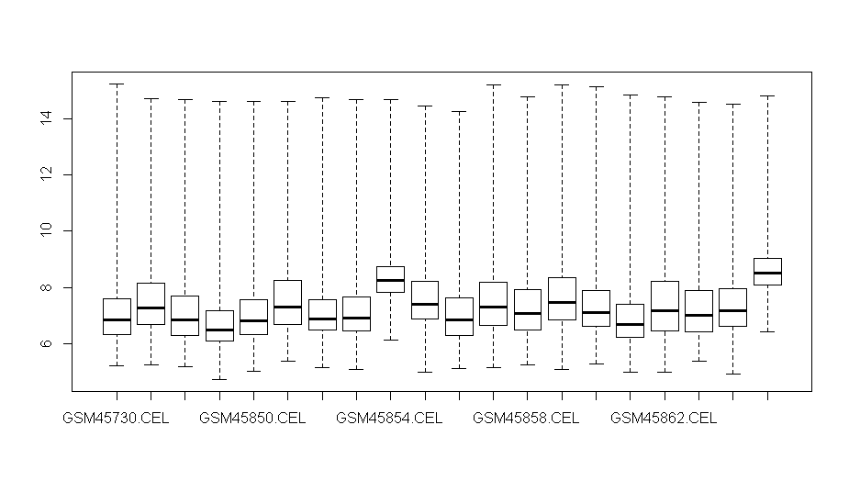
MyBioInfData – Boxplot

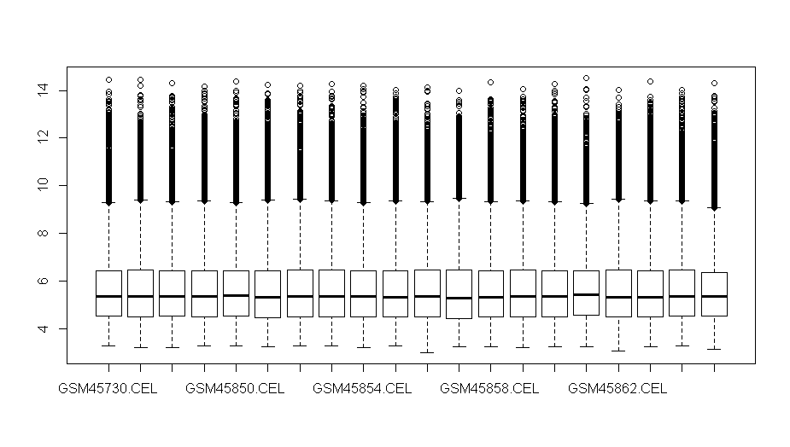
eset (Normalized) Boxplot

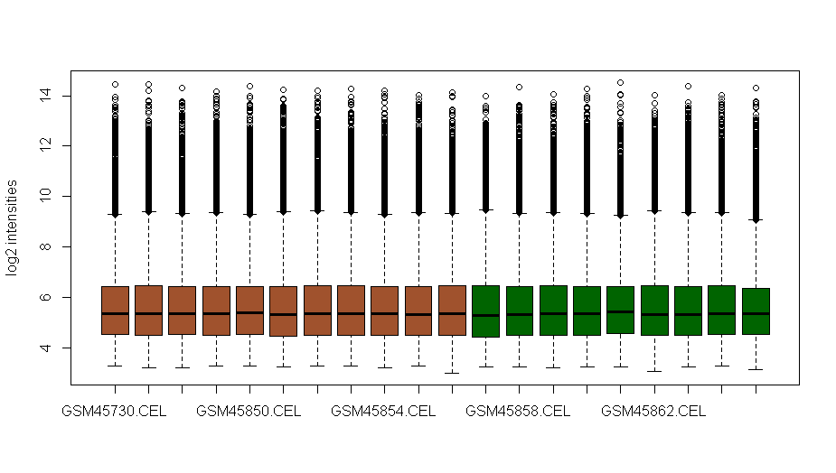
eset (Normalized) Color coded Boxplot – MA Plot

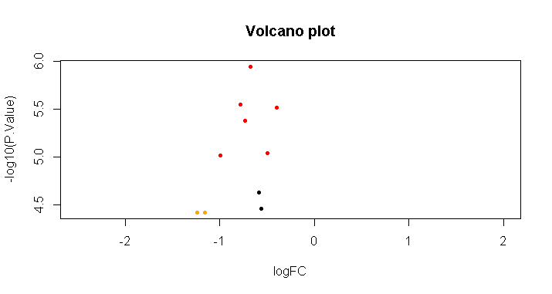
Volcano Plot for the ten observations

